PADE APPROXIMATION TO THE DENSITY OF STATES
Ben Heldt

Abstract: This paper presents Padé approximation as a way of analytically continuing one electron green’s functions from the imaginary axis to the real in order to represent the density of states. The density of states represents the transitions an atom in a given energy state can make to other energy states with either one more or one fewer electron. Padé approximation is ideally suited to approximating these kinds of functions because they are often the sum of delta functions; that is, they are functions that only have peaks (poles) at the values where excitations occur.

Background: We’re interested in representing the electronic structure of atoms (or molecules). Specifically, we want to be able to represent the excitation spectrum for some quantum system when it can be excited into a state with one fewer or one more electron. The physics behind this at the elementary level is relatively simple; given a Schrödinger equation where n represents the number of electrons in the system and the Hamiltonian and wave function are known, we can find the energy spectrum for this system. Then, if we solve the Schrödinger equation again, with it this time being , we now have three energy spectrums. We have one for n electrons, n+1 electrons, and n-1 electrons. Given this information we can construct an excitation spectrum from an original state (let’s say, the ground state of the n electron system,) to any other energy state with one more or fewer electron. This spectrum can be represented as the sum of delta functions, , and is called the density of states. Though this is straightforward conceptually, the calculations are not. This function is in fact the imaginary part of the function we hope to approximate, that follows the equation , where . Because the imaginary part of the function is unknown in general and is the ultimate function we hope to be able to represent, we cannot calculate this integral and generate an exact equation for . We can, however, calculate the function --that is, the function we want, on the imaginary axis—because is a one electron green’s function which can be calculated at certain points, called the matsubara points, on the imaginary axis. With this information we then need an approximation method that will fit a curve to these points and then continue the function accurately to the real axis.

Padé approximation fits a function of the form to a given set of inputted complex points and functional values for each of the complex points. I wrote a program which takes input in the form of the arrays (complex points) and (the functional values at those complex points).
The ultimate goal of the program I wrote is to represent this approximation in terms of the sum of weights over poles. That is, it will represent F(z) in the following form, where are weights for the , which are the poles of the function:
The program's first step utilizes Padé approximation to give the coefficients and in the relationship:
Where the two polynomials obey the recursion relationship:
In these equations, is the functional variable, the are the points at which the function is defined, and the are the padé coefficients. The padé coefficients are generated using another recursion relationship based upon the and values.
Next, the poles of the polynomial in the denominator are found, so F(z) can be rewritten as:
The final step finds the coefficients that correspond to the poles , and returns the values of those so that may be written:
We can find the values using partial fractions; starting from:
We can then write:
Then, matching up coefficients of the different powers of z, we get N +1equations to solve for our N+1 unknown values:
.
.
.
Solving this system of equations gives us a relationship for , which is:
Here, the and values are the roots of the polynomial . This gives us the relationship that we want; namely, we can now write with both and known.
It should be noted that the number of points inputted determines the order of the polynomials generated (and therefore the number of poles generated) for the approximation. For n values that are input, the order of the polynomials N will be and .
Results:
I found that the padé approximation technique works well to analytically continue functions from the imaginary axis to the real. Problems arose with the approximations at first because, as is clear from the recursion relationship that generates the polynomial coefficients, the order of points inputted and the range on which they are inputted can drastically affect the approximation. I found that when points were taken from either side of zero on the imaginary axis, the function on the real axis suffered. However, when
points were taken only from the positive half of the imaginary axis, the function on the real axis did well. We can see this behavior by looking at a practice function.
Figure one is the function we hope to represent. You can see that the function on the imaginary axis is smooth, whereas the function on the real axis has discontinuity in its derivative at the points -5 and 5. Padé approximation, luckily, does a good job of understanding these discontinuities even if all it knows about a function is its smooth behavior on the imaginary axis. That is, as long as the points used for the approximation are chosen well.
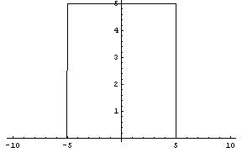
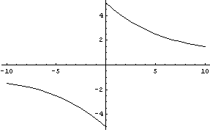
Figure 1: Imaginary parts on the real (left) and imaginary (axis) of the function we want to approximate.
I found that when the points for the approximation were taken symmetrically about zero on the imaginary axis, the approximation on the real axis suffered (Figure 2). However, when the points were taken only from the positive half of the imaginary axis, the function 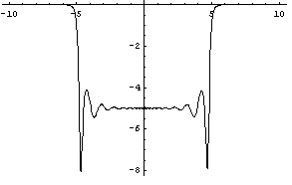
Figure 2: Imaginary part on the real axis, 80 point (40 pole) approximation
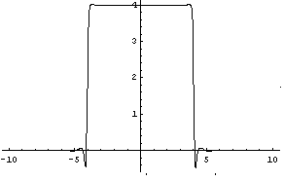
was a very good approximation on the real axis. Interestingly, the approximation on the imaginary axis does not represent the function well on the negative part of the imaginary 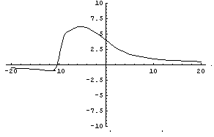
Figure 3: Imaginary parts on the real (left) and imaginary (right) axes, 60 point (30 pole) approximation.
axis (Figure 3), but this is not a problem. This is because if we consider that

(all the functions we look at, including this practice function, have this form), we note that . This tells us that must be even and must be odd. With this knowledge, we can assume that only the positive half of the approximation on that axis is correct and build the negative half by enforcing the constraint that Im[F(iω)]=-Im[F(-iω)]. Though it’s not imperative to be able to represent the function on the imaginary axis, it is nice to know that we can do it successfully.
Using this knowledge we are able to represent the functions we want on the real axis given certain points on the imaginary axis. Figure 4 shows plots of the imaginary part on the real axis of approximations taken using a generating program designed to simulate the green’s function at the matsubara points on the imaginary axis. Each plot
Figure 4: Plots of 50 point (25 pole) approximations taken from a generating program that gives functional values for known green's functions at the matsubara points. The plots differ only in the number of d-orbital electrons their original energy level has. From the top left and going clockwise, these plots approximate systems with five, six, seven and eight d-orbital electrons.
represents an excitation spectrum for some molecule beginning in some arbitrary energy level with different d-orbital electron fillings. The plots have five, six, seven and eight d-orbital electrons, respectively. The plots are exact because the functions to be generated were indeed simply the sum of delta functions. The padé approximation is at its best when this is the case, as it will produce a nearly exact approximation for functions of this form.

Conclusions and Work to Be Done:
This method of padé approximation and its representation and the sum of weight over poles is excellent choice for representing the density of states. In order to make sure it will behave properly if used for approximating systems that are not yet known, the program should be tested further with known systems.
Beyond that, the one problem with this method of approximation is the lack of stability (predictability) of the approximations as the order of the polynomials in the approximation gets very high. In order to increase the stability of the approximations, it may be a good idea to rewrite them in terms of the Chebyshev polynomials, a set of orthogonal polynomials on the range -1 to 1. Because these polynomials only operate on this range, as their order gets higher the contributions from these higher order terms begin to die off. The Chebyshev polynomials are defined as

Beyond those things, the algorithm that generates these padé approximations and rewrites them as the sum of weighs over poles should be useful.

